Project: Grazioso Salvare’s Web Application
Developer: Ryan Ferreira

Project Overview
This web application was developed for Grazioso Salvare to help them find dogs for search and rescue training from various animal shelters in the Austin Texas area. The Web Application allows users to filter between dogs who can perform rescues such as water rescues, mountain or wilderness rescue, disaster rescues or rescues for an individual person. This web application shows all the different animals that are in five shelters in Austin Texas and provides the user with a geolocation map that shows where the animals are located. The web application also shows a dashboard that displays animal records from MongoDB and filtering options. Upon toggling the various filtering options, a pie chart was chosen for the data visualization tool to show the user a visual representation of the distribution of animal breeds among the various rescue types.
Screenshots
Dashboard Homepage
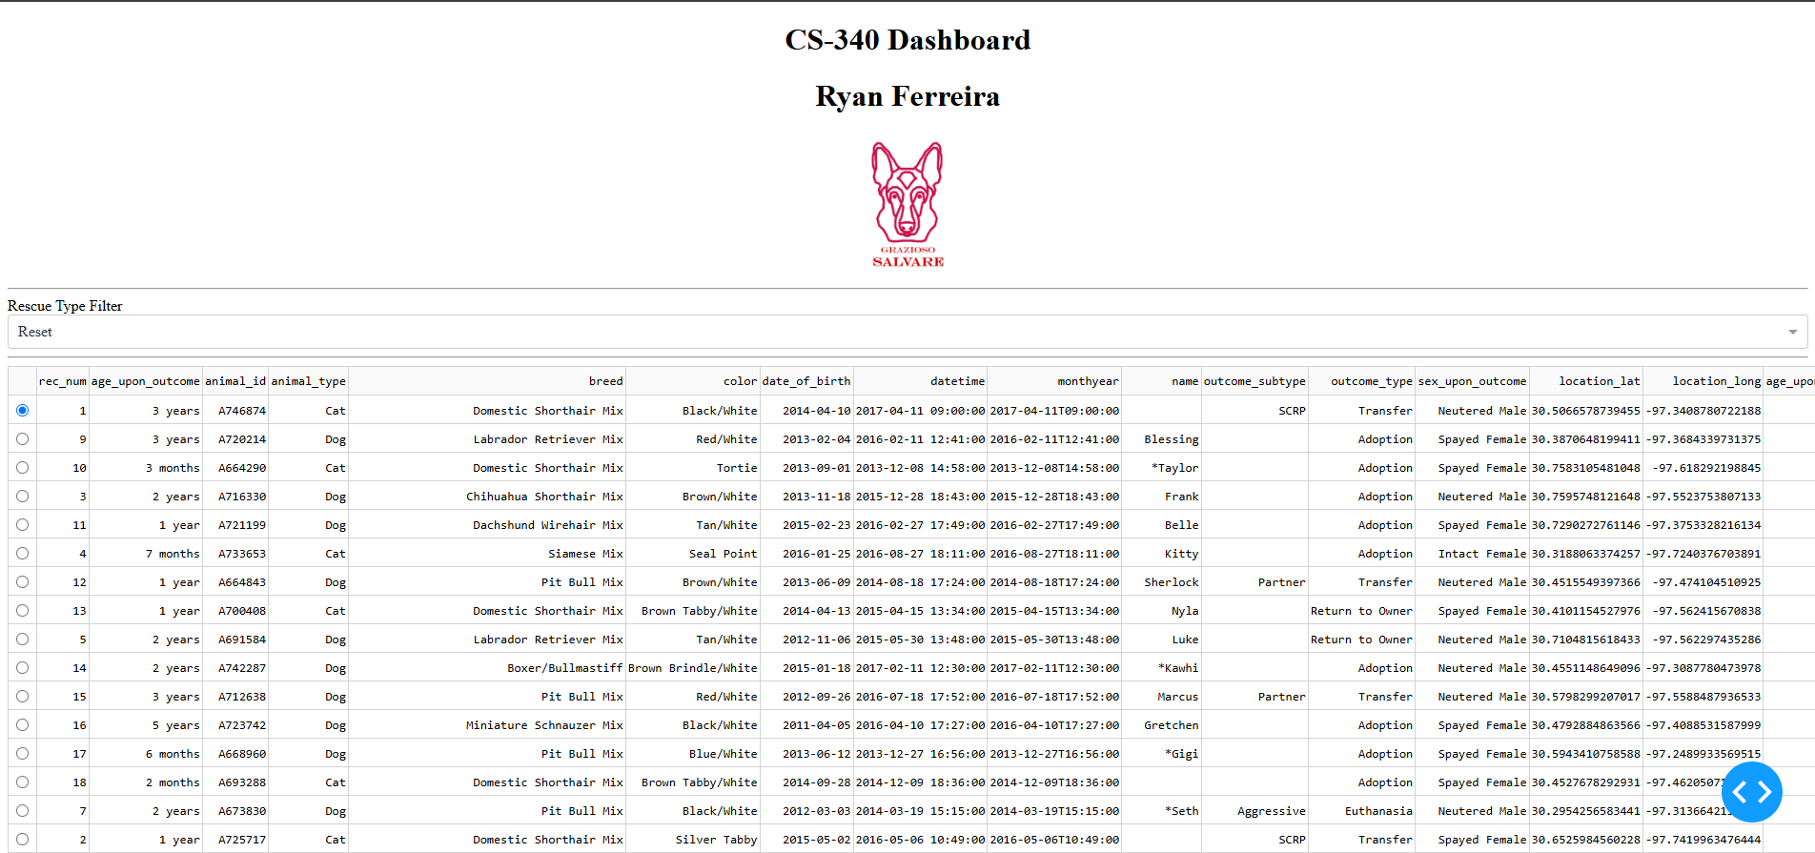

Water Rescue Filter
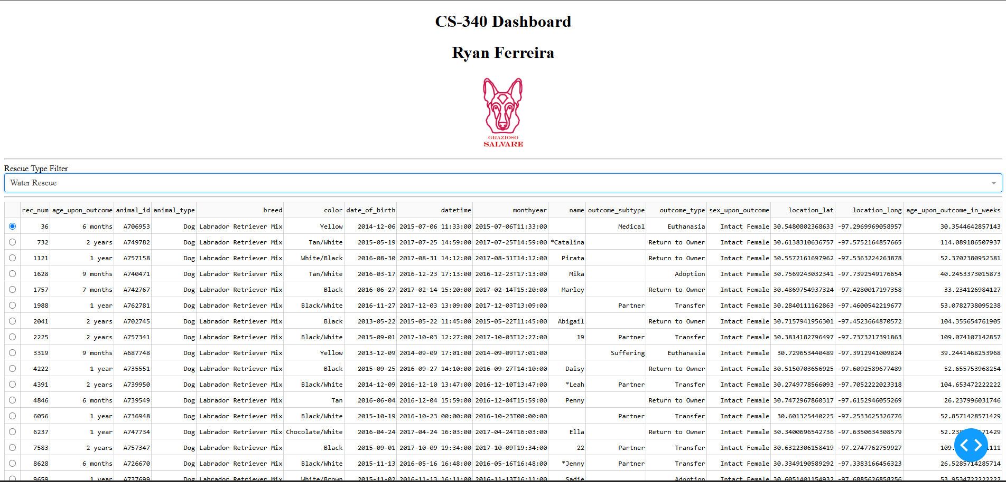

Bottom of Water Rescue Filter
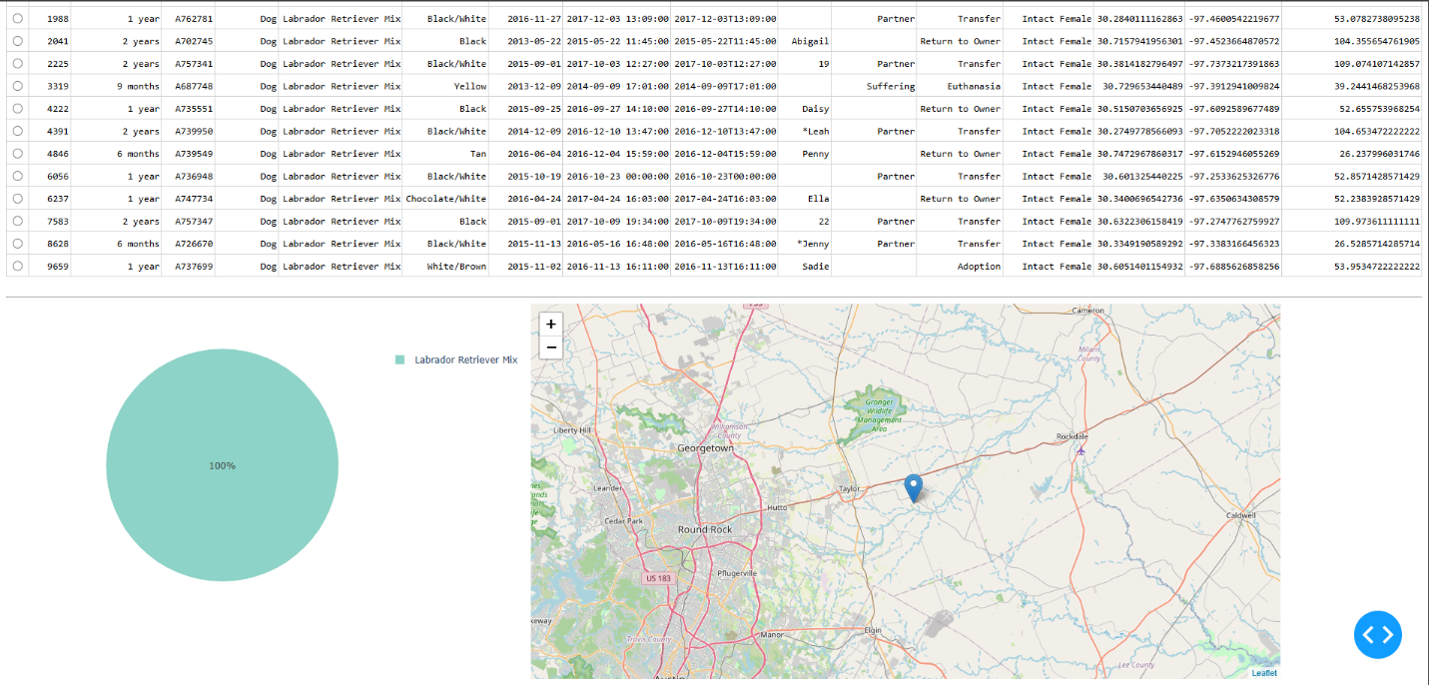

Mountain or Wilderness Rescue filter
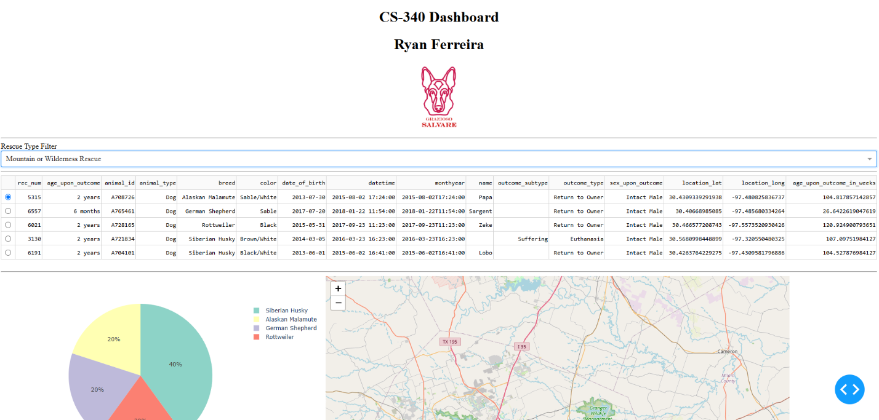

Bottom of Mountain or Wilderness Rescue Filter
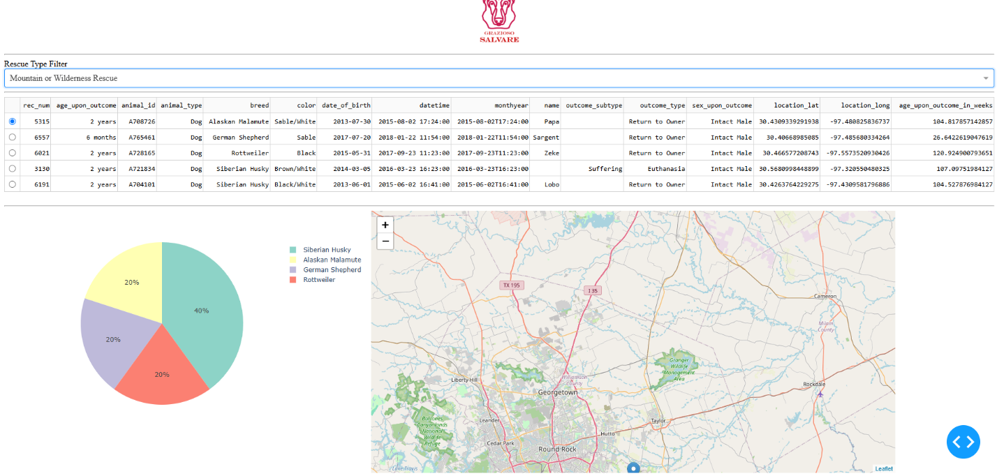

Disaster or Individual Tracking Filter
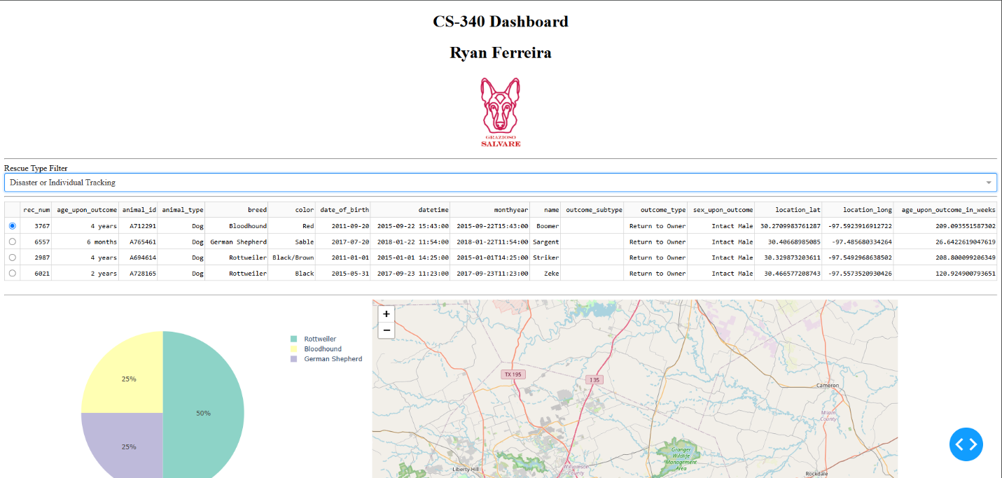

Bottom of Disaster or Individual Tracking Filter
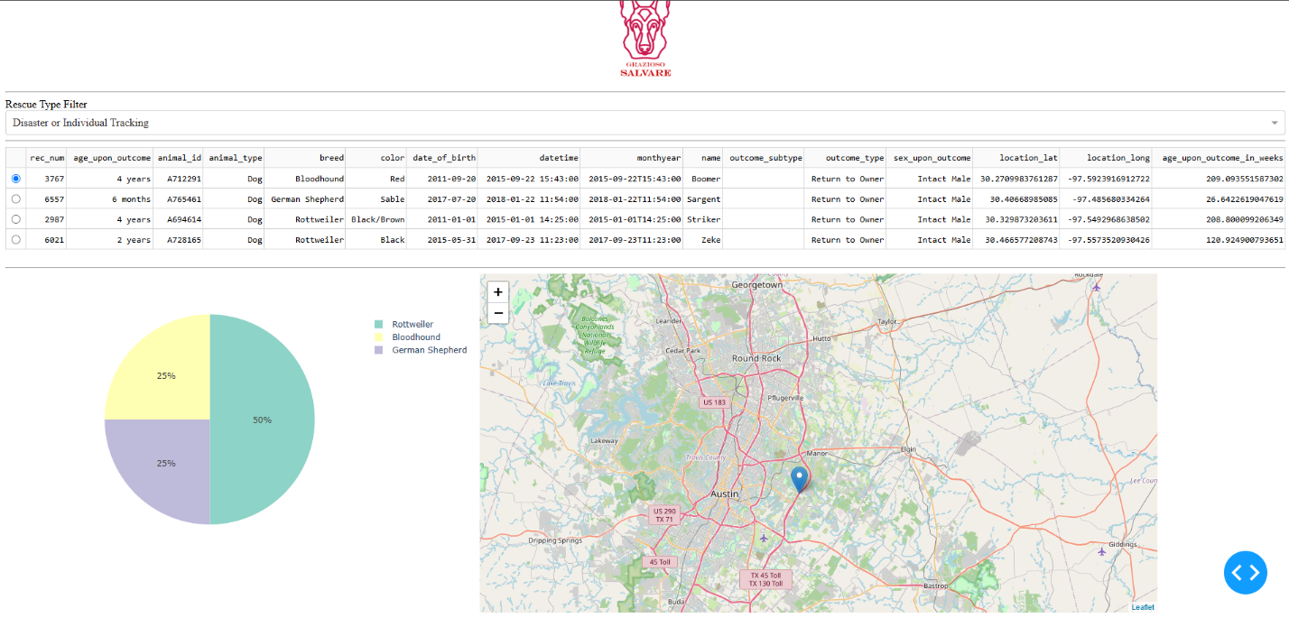

Reset Button
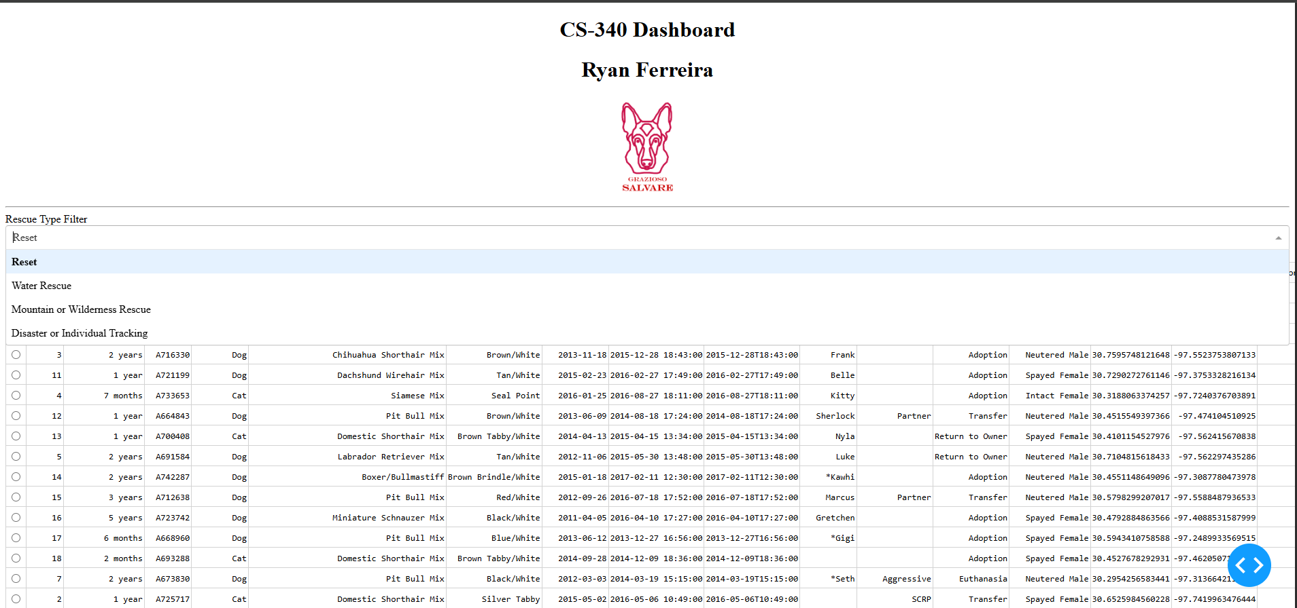

Bottom of page if user clicks reset button
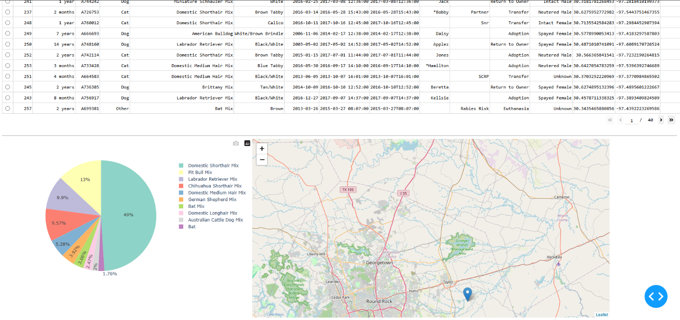

Tools and Rationale
MongoDB was used for the development of this web application as it works well with python through the PyMongo library and creates CRUD operations to create, read, update and delete data efficiently. MongoDB was used as the database component because of its ability to store document-based records within the dataset. Next, python was used to develop the CRUD module and implement the dashboard logic. Python libraries such as PyMongo, Pandas, NumPy and Pyplot were also used in the development of this web application. As mentioned earlier, PyMongo was used to connect MongoDB and Python. The Pandas was used for shape and organize the data that was used from MongoDB before displaying it on the dashboard. Pyplot was used to generate the pie chart shown on the web application that updates dynamically which the filters are applied. The Dash framework was applied as it provided the view and controller components of the web application by allowing me to build the interactive dashboard without the need for JavaScript. To develop this application, I used codio as it provides a cloud-based environment to allow me to use both MongoDB and Python. The Python IDE that was used for the development of this web application was Jupyter notebook. The resources that were used for this project were the SNHU CS-340 courese materials, specifically the CS 340 Dashboard Specifications document which helped me gain insight into how to develop and deploy this web application. Per the project’s requirement, I also used the Grazioso Salvare Logo and the data set that was used is the Austin Animal Center Outcomes.

Steps Taken & Challenges Encountered
To reproduce the project, you first must have created a CRUD Python Module that connects to MongoDB and the Austin Animal Center Outcomes dataset. In the CRUD module, you must implement create, read, update and delete functionalities. Next create an ipynb file using Jupyter notebook then import Jupyter notebook version of dash. Next, we need to import all the necessary python module imports for the dashboard components of the web application. You may also need to import all the necessary libraries such as PyMongo, Pandas, Numpy and Pyplot. After that, you must ensure that the Database is connected via your CRUD Module. Next create the dashboard layout. Note: If you want to reproduce this project for another purpose, this is where you might want to add a different title or logo. But for the sake of this project, this is the part where I added my title, name and logo along with all my filter options such as filtering the Water Rescue, Mountain or Wilderness Rescue and Disaster or Individual Tracking rescue and the reset button. After that, I added a call back where it dynamically updates the table. Next, I added a pie chart that shows the distribution of which rescues types are being filtered. If you plan on reproducing this project, you are welcome to choose the right data visualization tool for your scenario. Finally, I added a map of Austin Texas that displays the locations of the animals. Finally test your web application to ensure that the logo, filter options and map are displayed properly.
A challenge that I personally ran into when developing this application is callback errors, to overcome this I had to go back and change the update_styles function that selects all the records when none is selected. Another issue that I ran into was indentation problems when adding me rescue filters and variable mismatches as a template was used for this project. The last challenge that I encountered was trying to figure out the best data visualization tool. In the assignments resources I noticed that they used pie charts as an example. I wanted by project to stand out so I opted to initially use a histogram chart, I decided that because I wanted the user to see the frequencies of a breed when a filter was applied. It looked good when a filter was applied. However, when the reset filter was applied, the histogram looked too cluttered and hard to read for the user, so I changed the chart to a pie chart.

